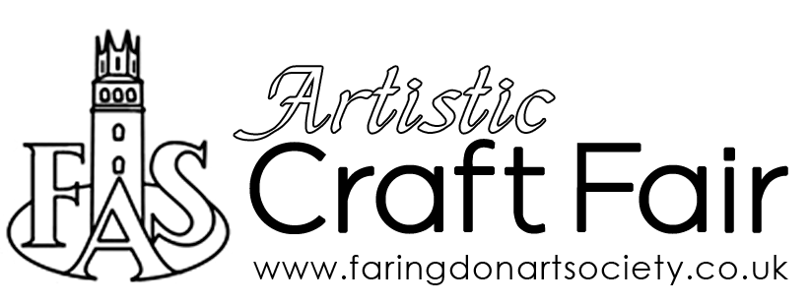
Application Form

Date | Saturday 4 December 2021
Time | 10am-3pm (vendor set up from 9.30am)
Venue | The Corn Exchange, Faringdon
Name
Email/Contact Number
Member Yes / No | Membership is required for insurances purposes. If you are a Non-Member then you will need to purchase FAS membership (£10) following the allocation of a table (available on website).
Please describe the goods that you wish to sell

If you can include a couple of images of the crafted goods you are planning to sell that would be very helpful. (Artists need not do this).
Please return completed forms to faringdonartsociety@gmail.com
Please note this is a preliminary form, indicating an expression of interest in the event, and does not therefore constitute the reservation of a table.
There are a limited number of tables and if demand exceeds availability, then priority will be given to crafters and makers. All applications will be assessed once the closing date has passed.
You will be contacted in due course to confirm (or otherwise) the allocation of a table.

Thank you for your interest and we will be in touch soon.

