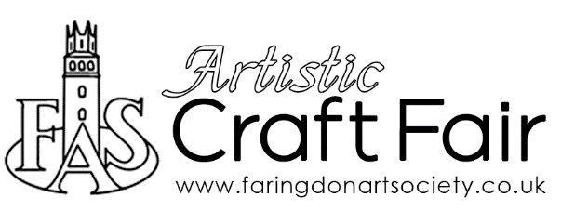
Saturday 7 August 2021
10am-3pm (vendor set up from 9.30am)
The Corn Exchange, Faringdon SN7 7JA

The intention of the FAS Artistic Craft Fair is to provide an opportunity for local makers and crafters, producing genuine personal creations, to showcase their work with a sales opportunity.
The exhibitor is to be the maker of items.
No imported or resale goods will be permitted. Food items and garments will not be considered. FAS reserves the right to use discretion in items to be, or on, offer.
You will be advised if your application has been successful at least one month prior to the event – you will be invited to purchase your table space (for 2021 we are looking at around £10-15 – non-members will be asked to pay an additional £10, which will include free FAS membership)

