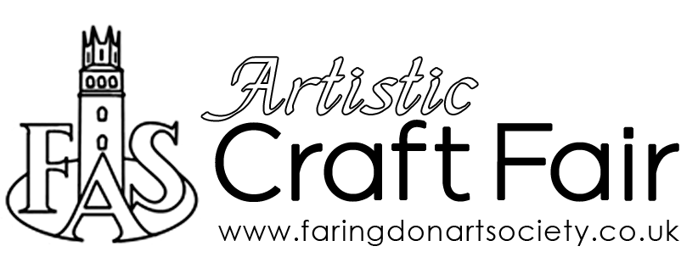
Application Form

Date | Saturday 7 August 2021
Time | 10am-3pm (vendor set up from 9.30am)
Venue | The Corn Exchange, Faringdon
Name
Address
Contact Number
/email
Please describe the goods that you wish to sell

If you can include a couple of images of the goods you are planning to sell that would be very helpful.
Completed forms should be returned to faringdonartsociety@gmail.com
Please note this is a preliminary form indicating an expression of interest in the event and does not therefore constitute the reservation of a table.
You will be contacted nearer to the date to confirm the allocation of a table for your use. This is dependent upon the number of tables possible, or those we may have available due to any remaining social distancing rules.
Thank you for your interest we will be in touch soon.

